

**INSTITUTE FOR ADVANCED COMPUTING AND SOFTWARE DEVELOPMENT, AKURDI, PUNE**

**Examination Portal**

PG-DAC March 2024

Submitted By:

Group No: 100

Roll No. Name.

243211 Siddhiraj Pawar

243220 Vedant Kalamkar

**Mrs. Monika Sindhikar Mr. Rohit Puranik**

Project Guide Centre Coordinator

## ABSTRACT

The Examination Portal is designed to streamline and modernize the management of quizzes and exams in educational settings. By leveraging the capabilities of a web-based platform, the portal provides an efficient and user-friendly solution for both educators and students. Educators, acting as administrators, can effortlessly create, update, and manage quizzes, questions, and categories through a centralized interface. This functionality significantly reduces the administrative burden and ensures that all aspects of the examination process are handled with precision and ease. For students, the portal offers a seamless experience for accessing quizzes, submitting answers, and reviewing their performance. With the ability to participate in quizzes online, students can engage with their coursework from any location, at their convenience. This approach not only enhances the learning experience but also promotes flexibility and accessibility, catering to diverse student needs and schedules. The system is designed with robust data management capabilities, ensuring that user data, quiz information, and results are securely stored and efficiently managed. This allows for accurate tracking of student performance and timely updates of quiz content. By integrating these features into a single, cohesive platform, the Examination Portal addresses common challenges in traditional examination systems, such as logistical issues and data management inefficiencies.

.

## ACKNOWLEDGEMENT

I take this occasion to thank God, almighty for blessing us with his grace and taking our endeavor toa successful culmination. I extend my sincere and heartfelt thanks to our esteemed guide, Mrs. Monika Sindhikar for providing me with the right guidance and advice at the crucial juncture sand for showing me the right way. I extend my sincere thanks to our respected Centre Co-Ordinator Mr. Rohit Puranik, for allowing us to use the facilities available. I would like to thank the other faculty members also, at this occasion. Last but not the least, I would like to thank my friends and family for the support and encouragement they have given me during the course of our work.

Siddhiraj Pawar (240341220198)

Vedant Kalamkar (240341220212)

IACSD *e-Nirvachan*

**Table of Contents**

|  |  |  |
| --- | --- | --- |
| **Sr.No** | **Description** | **Page No.** |
| 1 | Introduction | 1 |
| 2 | SRS | 4 |
| 3 | Database design | 9 |
| 4 | Diagrams | 15 |
| 4.1 | ER Diagram | 16 |
| 4.2 | Data Flow Diagram | 17 |
| 5 | UML Diagrams | 18 |
| 5.1 | Use Case Diagram | 18 |
| 5.2 | Activity Diagram | 19 |
| 5.3 | Class Diagram | 20 |
| 5.4 | Sequence Diagram | 21 |
| 6 | Snapshots | 23 |
| 7 | Conclusion |  |
| 8 | Future Scope |  |
| 9 | References |  |

## INTRODUCTION

The Examination Portal is engineered to meet the evolving needs of modern educational environments, offering a suite of features that transform traditional assessment methods into a streamlined digital experience. This system caters to both administrative and educational functions, providing a robust framework for managing quizzes and exams efficiently.

For administrators, the portal delivers comprehensive tools for overseeing the entire examination lifecycle. It supports the creation and customization of quizzes, including the addition and modification of questions, categories, and quiz settings. This flexibility ensures that assessments can be tailored to specific learning objectives and instructional needs. Additionally, the portal integrates with data storage solutions to maintain a secure and organized repository of all exam-related information, including results and analytics. Educators benefit from the portal's ability to facilitate real-time updates and modifications. Whether updating a question or altering quiz parameters, the portal's intuitive interface allows for swift changes without disrupting the examination schedule. This responsiveness enhances the ability to adapt to curriculum changes and ensure that assessments remain aligned with educational goals.

For students, the Examination Portal offers an accessible and engaging platform for completing quizzes. The system supports a variety of question formats and provides instant feedback on performance, which fosters a more interactive and formative learning experience. By enabling students to access quizzes from any location, the portal accommodates diverse learning environments and schedules, making education more inclusive and flexible.

Security and privacy are paramount in the Examination Portal. The system employs robust authentication mechanisms to protect user data and ensure that only authorized individuals can access sensitive information. By adhering to best practices in data protection, the portal safeguards both academic integrity and user privacy.

### Purpose

The purpose of the Examination Portal is to modernize and streamline the management and execution of quizzes and exams, enhancing accessibility, flexibility, and efficiency for administrators, educators, and students.

### Scope

The scope of the Examination Portal encompasses the creation, management, and administration of quizzes and exams, including user management, question handling, and result tracking, all within a secure and user-friendly web interface.

### Objective of Project on Examination Portal :

The objective of the Examination Portal project is to develop a comprehensive, online platform that streamlines the creation, administration, and evaluation of quizzes and exams, providing a secure and efficient environment for users and administrators to manage and track assessments seamlessly. This platform aims to enhance the examination process by automating tasks, improving accessibility, and delivering accurate results with minimal manual intervention.

### Functionalities provided by Examination Portal are as follow:

### 1. User Registration and Authentication: Allows users to create accounts, log in, and securely access the portal based on their roles, either as administrators or regular users.

### 2. Quiz Management: Enables administrators to create, update, and delete quizzes. They can define quiz parameters such as time limits, categories, and question types.

### 3. Question Management: Facilitates the addition, modification, and deletion of questions associated with quizzes. Administrators can organize questions into different categories and formats.

### 4. Category Management: Allows administrators to manage categories for organizing quizzes and questions, including adding new categories, updating existing ones, and removing outdated categories.

### 5. Quiz Attempt and Submission: Provides users with the ability to attempt quizzes, submit answers, and view results. Users can track their progress and review their performance.

### 6. Results Management: Administers the generation and management of quiz results, including grading and reporting. Users can access their individual results, while administrators can view aggregate data.

### 7. Profile Management: Lets users and administrators manage their profiles, including updating personal information and changing passwords.

### 8. Security and Access Control: Ensures secure access to the portal by implementing role-based permissions and encryption for sensitive dat

## REQUIREMENTS

### Functional Requirements

1.User Registration and Authentication:

* Registration: Users must be able to create accounts by providing necessary details such as username, email, and password. The system should validate the input data, ensure unique usernames and emails, and store user credentials securely.
* Login: Users should be able to log in using their registered credentials. The system should authenticate users and provide access based on their roles (e.g., administrator or regular user).
* Password Recovery: The portal must offer a mechanism for users to recover or reset their passwords via email verification or security questions.

2.Quiz Management:

* Creation: Administrators must be able to create new quizzes, specifying details such as title, description, category, time limit, and question types.
* Modification: Administrators should be able to update existing quizzes, including changing quiz parameters or adding/removing questions.
* Deletion: Administrators need the ability to delete quizzes from the system, including all associated data such as questions and results.

3.Question Management:

-Addition: Administrators should be able to add new questions to the system, specifying -details such as question text, options, correct answers, and associated quiz.

-Modification: Administrators must be able to edit existing questions, including updating question text, options, and answers.

-Deletion: Administrators should be able to remove questions from the system, including from associated quizzes.

4.Category Management:

-Creation: Administrators must be able to create new categories for organizing quizzes and questions.

-Modification: Administrators should be able to update existing categories, including renaming or reassigning quizzes and questions.

Deletion: Administrators need the ability to delete categories, ensuring that associated quizzes and questions are properly handled.

5.Quiz Attempt and Submission:

-Attempt: Users must be able to access and start quizzes based on their availability and permissions. The system should display questions one at a time or in a selected format.

6.Results Management:

* Grading: The system must automatically grade quizzes based on the predefined correct answers and provide a score.
* Reporting: Results should be compiled and presented to users in a clear format, including scores.

7.Profile Management:

-Change Password: Users must be able to change their passwords through a secure process.

8.Security and Access Control:

* Role-Based Access: The system must enforce role-based permissions, ensuring that users and administrators can only access functionalities relevant to their roles.
* Data Encryption: Sensitive data, including user credentials should be encrypted during storage and transmission.

### Non-Functional Requirements:

1.Performance:

-Response Time: The system should provide a response time of under 2 seconds for most user interactions, such as logging in, starting a quiz, and submitting answers.

-Scalability: The portal must be able to handle simultaneous users without significant degradation in performance, ensuring that both users and administrators experience consistent performance.

2.Reliability:

-Availability: The system should have an uptime of 99.9%, minimizing downtime and ensuring that users can access the portal whenever needed.

-Error Handling: The portal must include comprehensive error handling mechanisms to provide users with clear error messages and prevent system crashes.

S

3.Security:

-Data Protection: Sensitive user data, such as passwords , should be stored and transmitted using encryption

-Authentication: The system must use secure authentication methods, including hashed passwords and secure token-based sessions, to protect user accounts.

-Authorization: Role-based access control should be implemented to ensure that only authorized users can access specific functionalities based on their roles.

4.Usability:

-User Interface: The portal should have an intuitive and user-friendly interface, with consistent design elements and clear navigation paths to enhance user experience.

-Accessibility: The system should be accessible to users with disabilities, following WCAG (Web Content Accessibility Guidelines) to ensure compatibility with screen readers and other assistive technologies.

5.Maintainability:

-Code Quality: The codebase should be well-structured and documented to facilitate easy maintenance and updates. This includes adhering to coding standards and practices.

-Modular Design: The system should be designed in a modular fashion, allowing for the easy addition of new features and components without impacting existing functionality.

6.Compatibility:

-Browser Support: The portal must be compatible with major web browsers, including Google Chrome, Mozilla Firefox, Safari, and Microsoft Edge, ensuring a consistent experience across different platforms.

7.Compliance:

-Data Privacy: The portal should comply with relevant data privacy regulations (e.g., GDPR, CCPA) to ensure that user data is handled and stored appropriately.

-Legal Requirements: The system must adhere to any applicable legal requirements related to online exams and user data management.

### Other Requirements:

**Hardware and Network Interfaces:**

Back-end Server Configuration:

* Intel Pentium-IV Processor
* 128 MB RAM

Front-end Client Configuration:

* Intel Pentium-III @ 650 MHz Processor
* 128 MB SDRAM
* 10 GB Hard Disk Drive
* 104 Keys Keyboard
* PS2 Mouse with pad

### Software Interfaces:

Software configuration for back-end Services:

* Java EE
* Spring Boot, JPA
* MySQL

- STS 3.9.18

Software configuration for front-end Services:

* ReactJS
* HTML, CSS, JS
* Bootstrap
* VS Code

# DATABASE DESIGN

**Database Design**

The following table structures depict the database design.

Table 1: User Data:

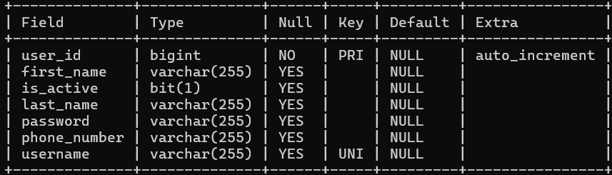

Table 2: Role Data:

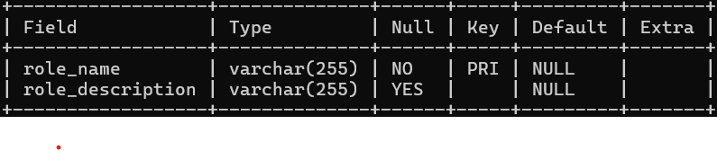

Table 3:Category Data

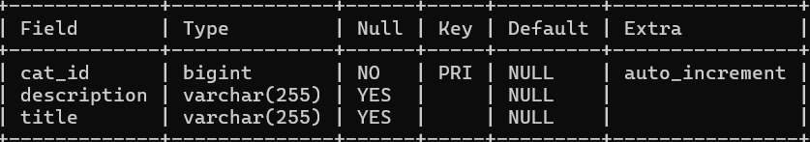

Table 4:Quizz Data

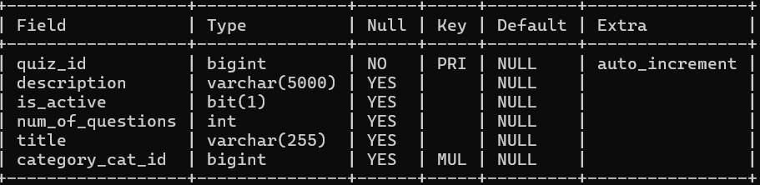

Table 5: Question Data:

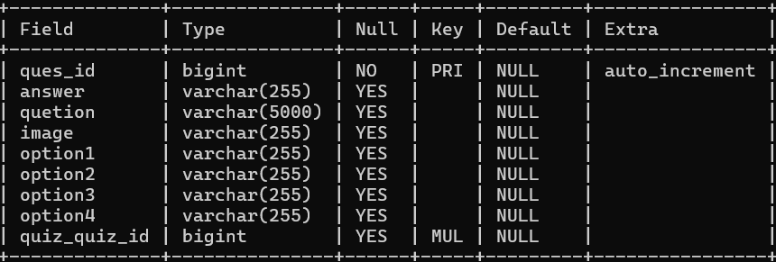

Table 6: Quiz Result Data:

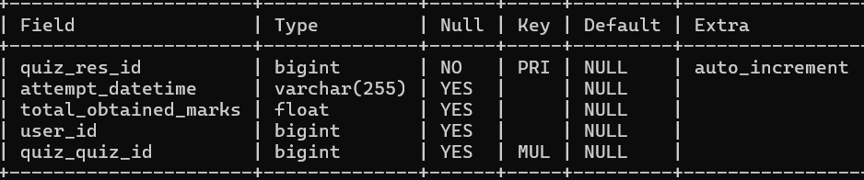

# Diagrams

**4.1 Entity Relationship Diagram:**

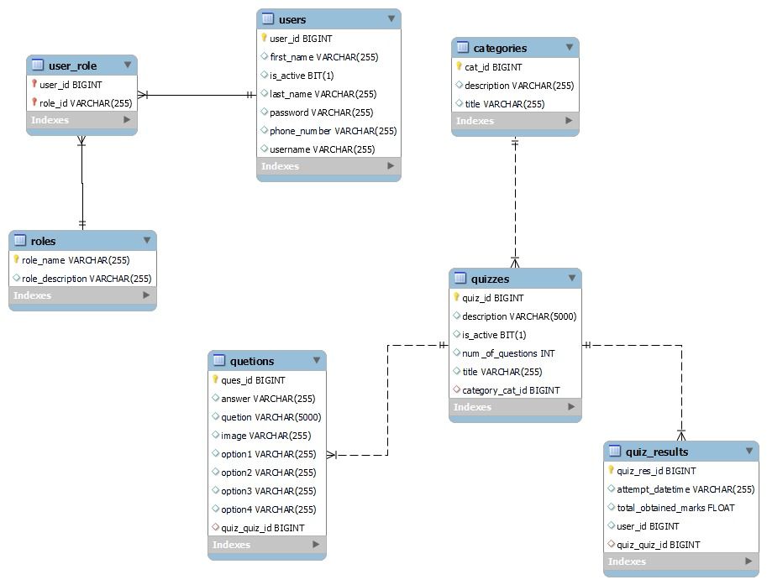

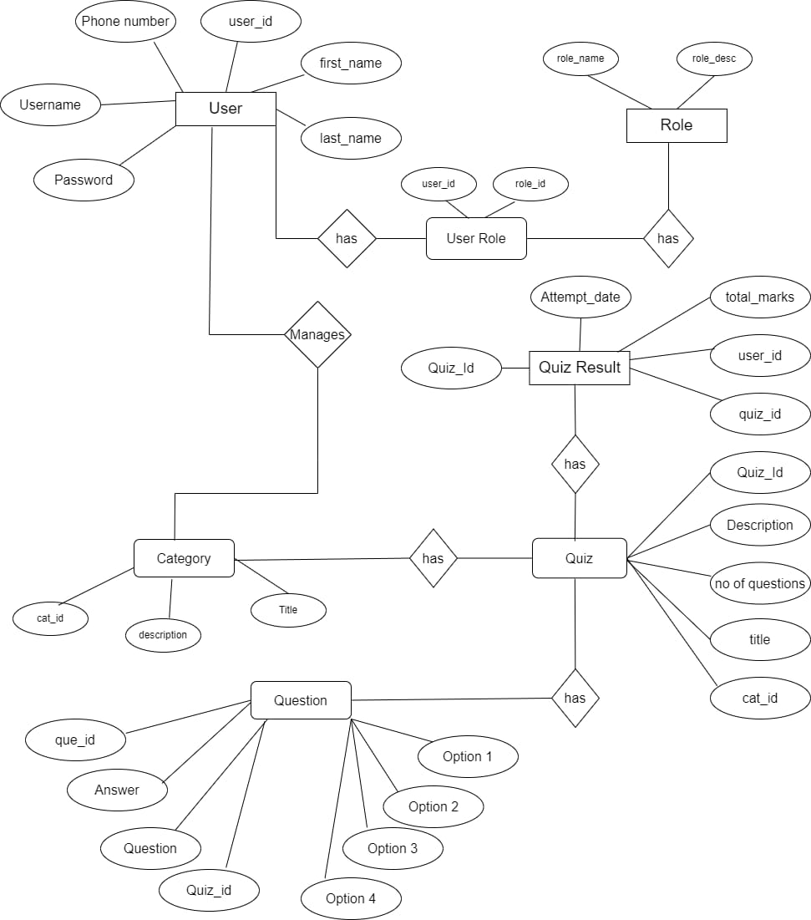

**4.2 Data Flow Diagram**

**Level 0:**

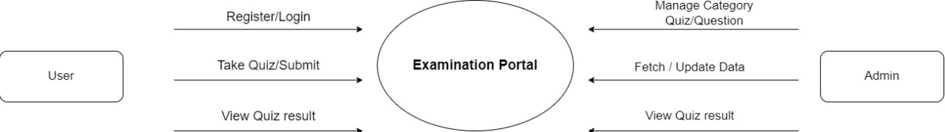

**Level 1 :**

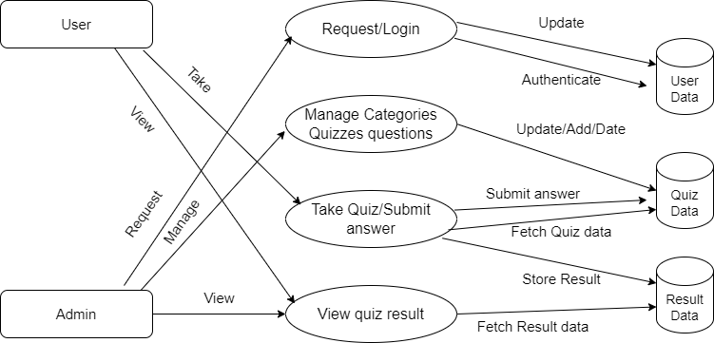

**5. UML Diagrams**

**5.1 Uses Case Diagram**

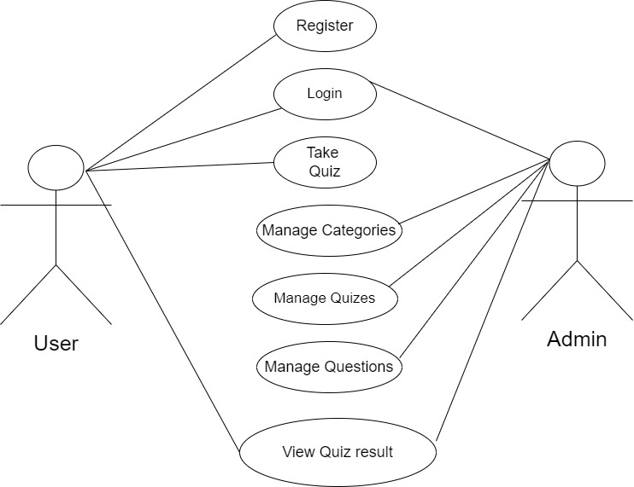

**5.2 Activity Diaram:**

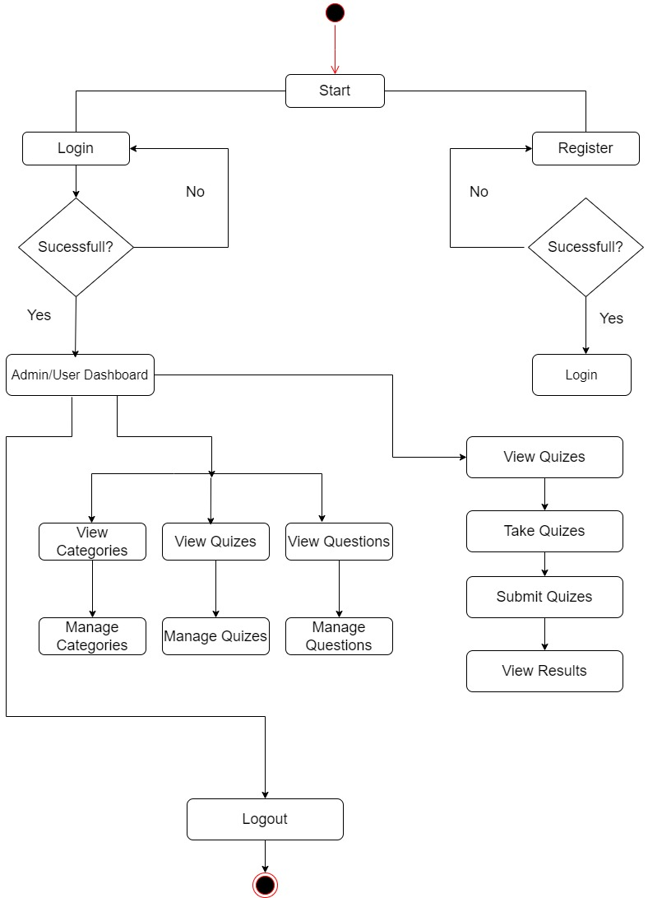

**5.3 Class Diagram**

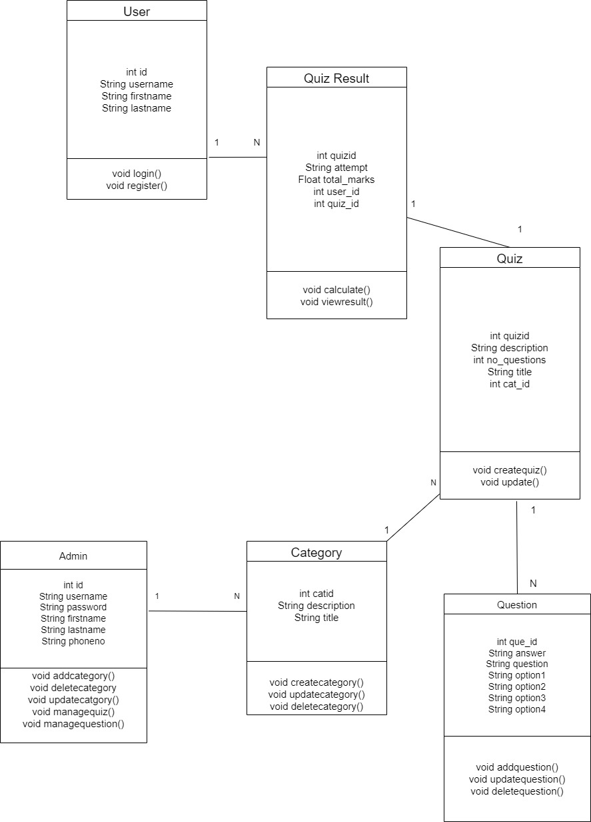

**5.4 Sequence Diagram: For User**

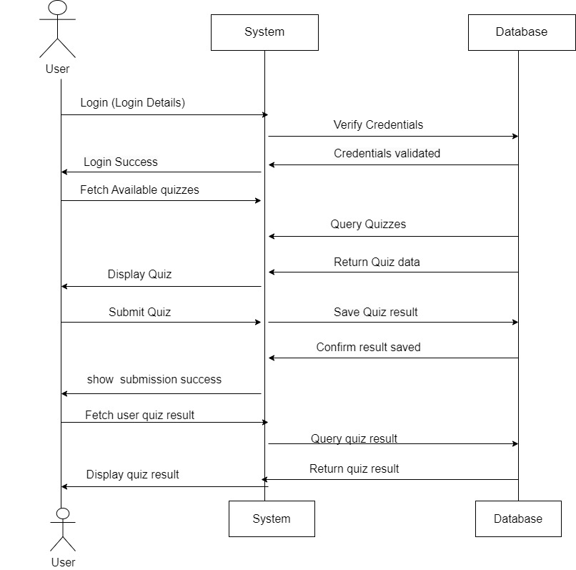

**5.4 Sequence Diagram: For Admin**

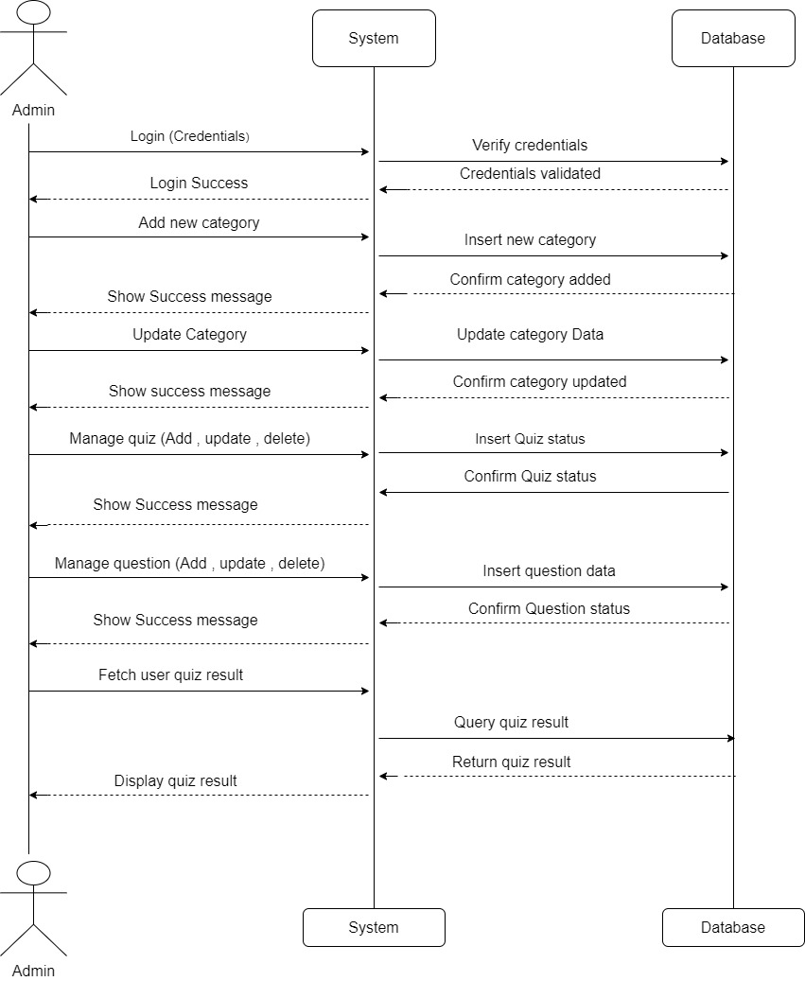

**Login Page :**

# 6.Snapshots

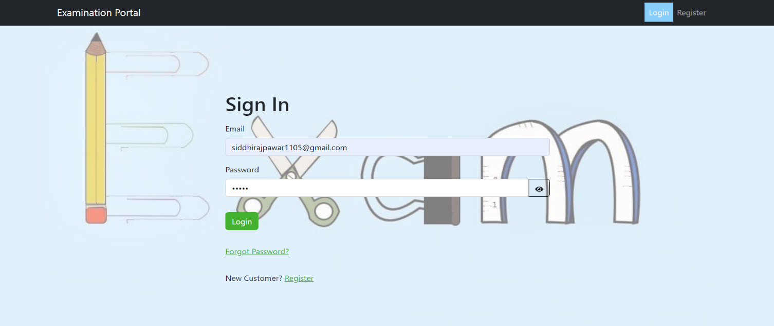

**Register Page :**

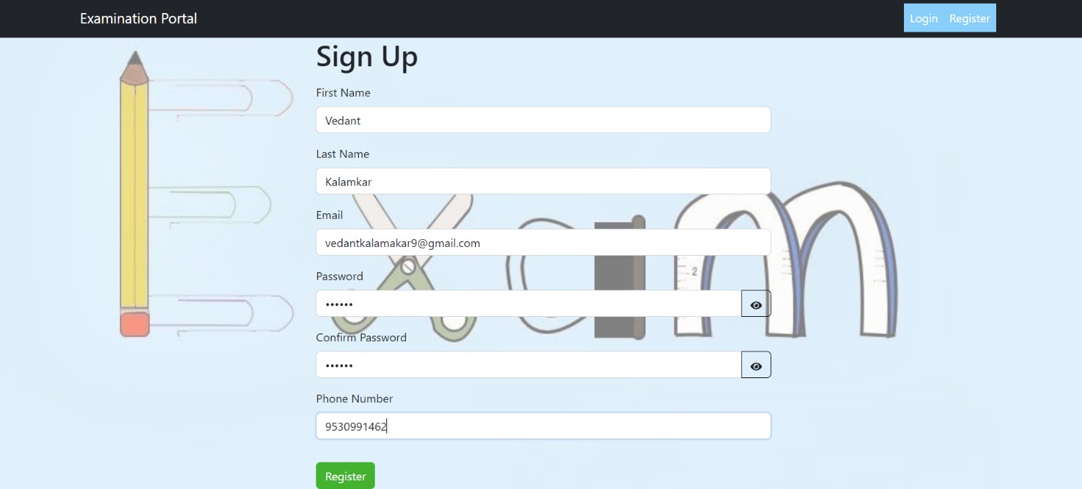

**Admin Dashboard:**

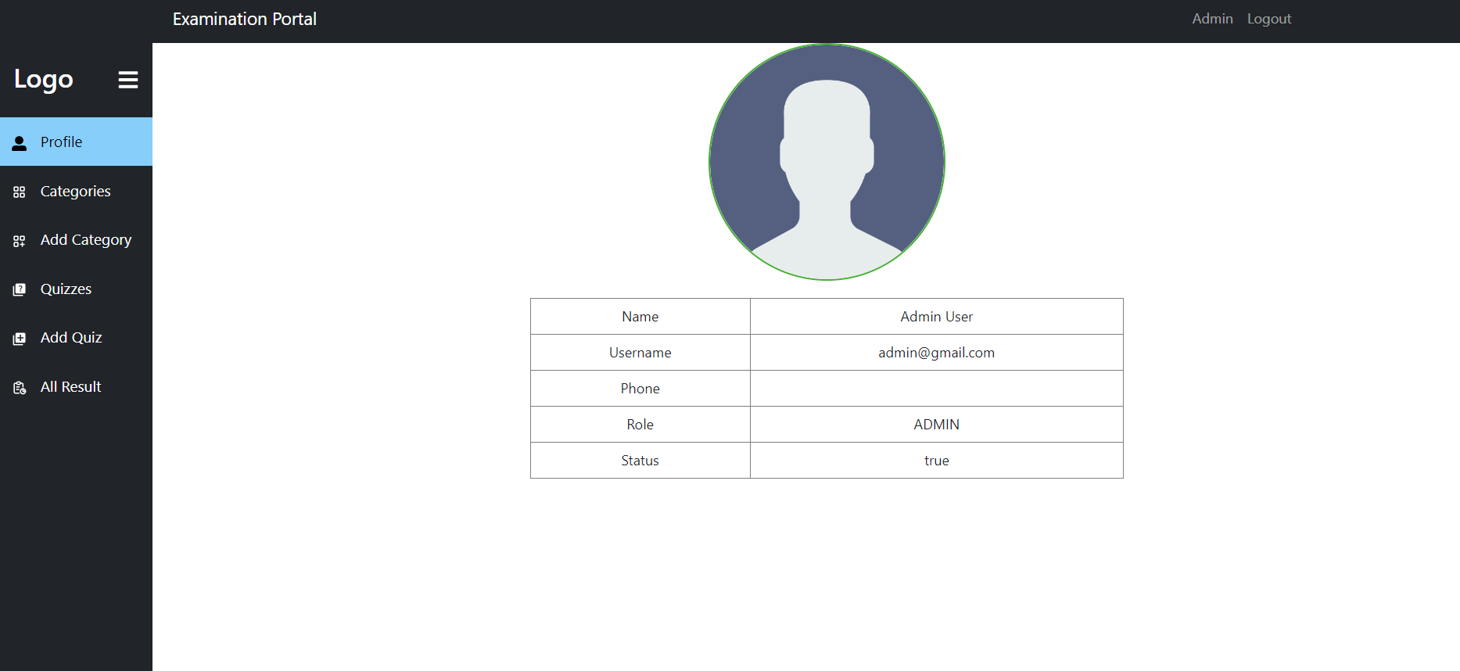

**Admin Category :**

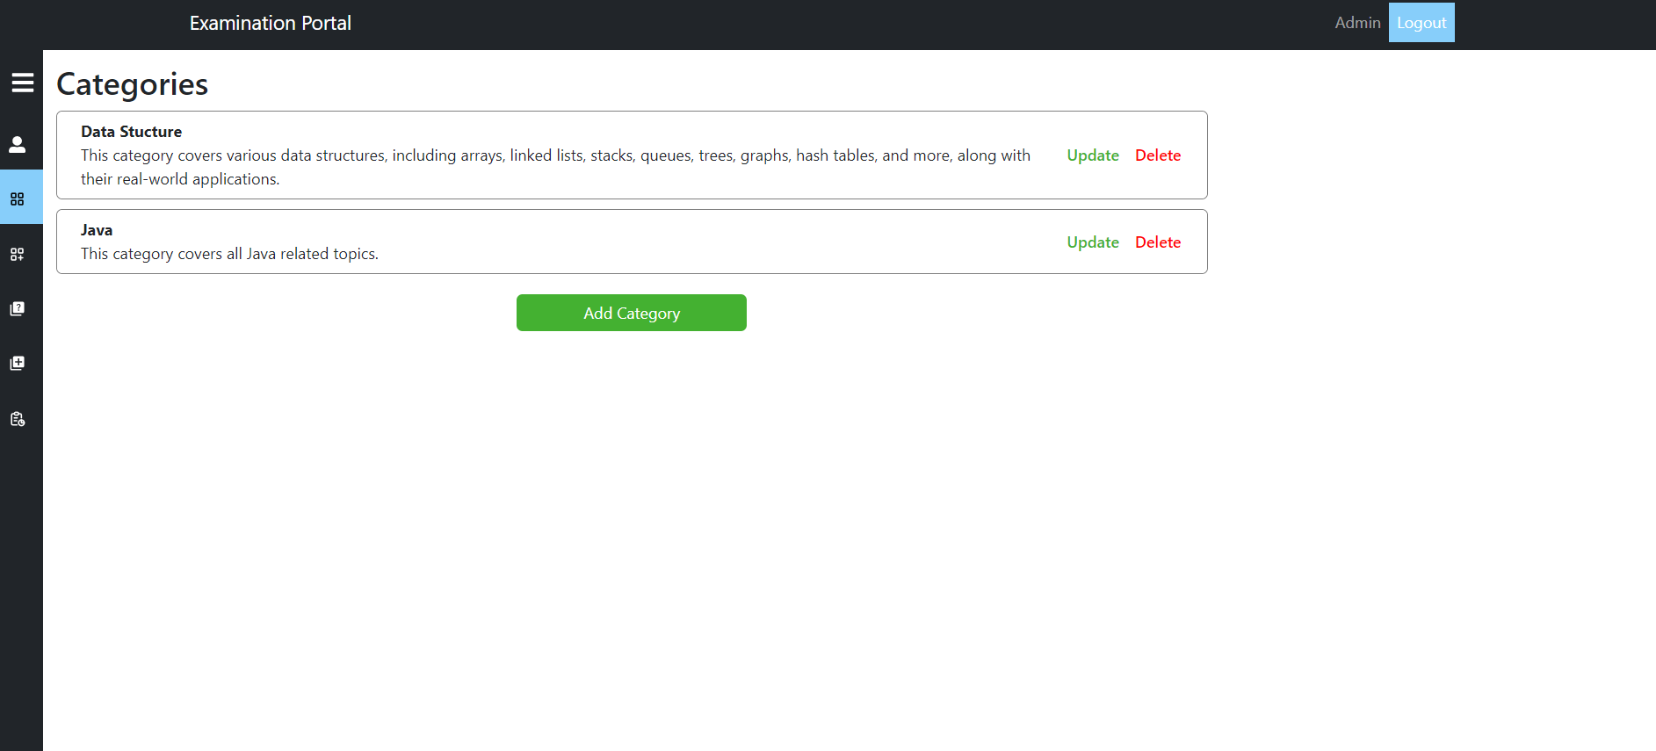

**Admin AddCategory Page:**

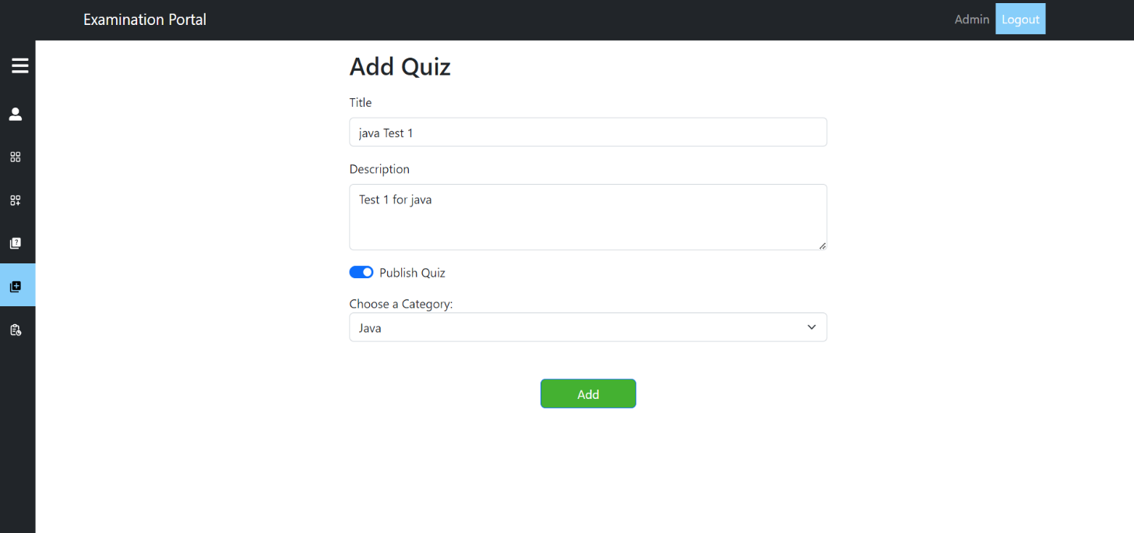

**Admin AddQuiz Page:**

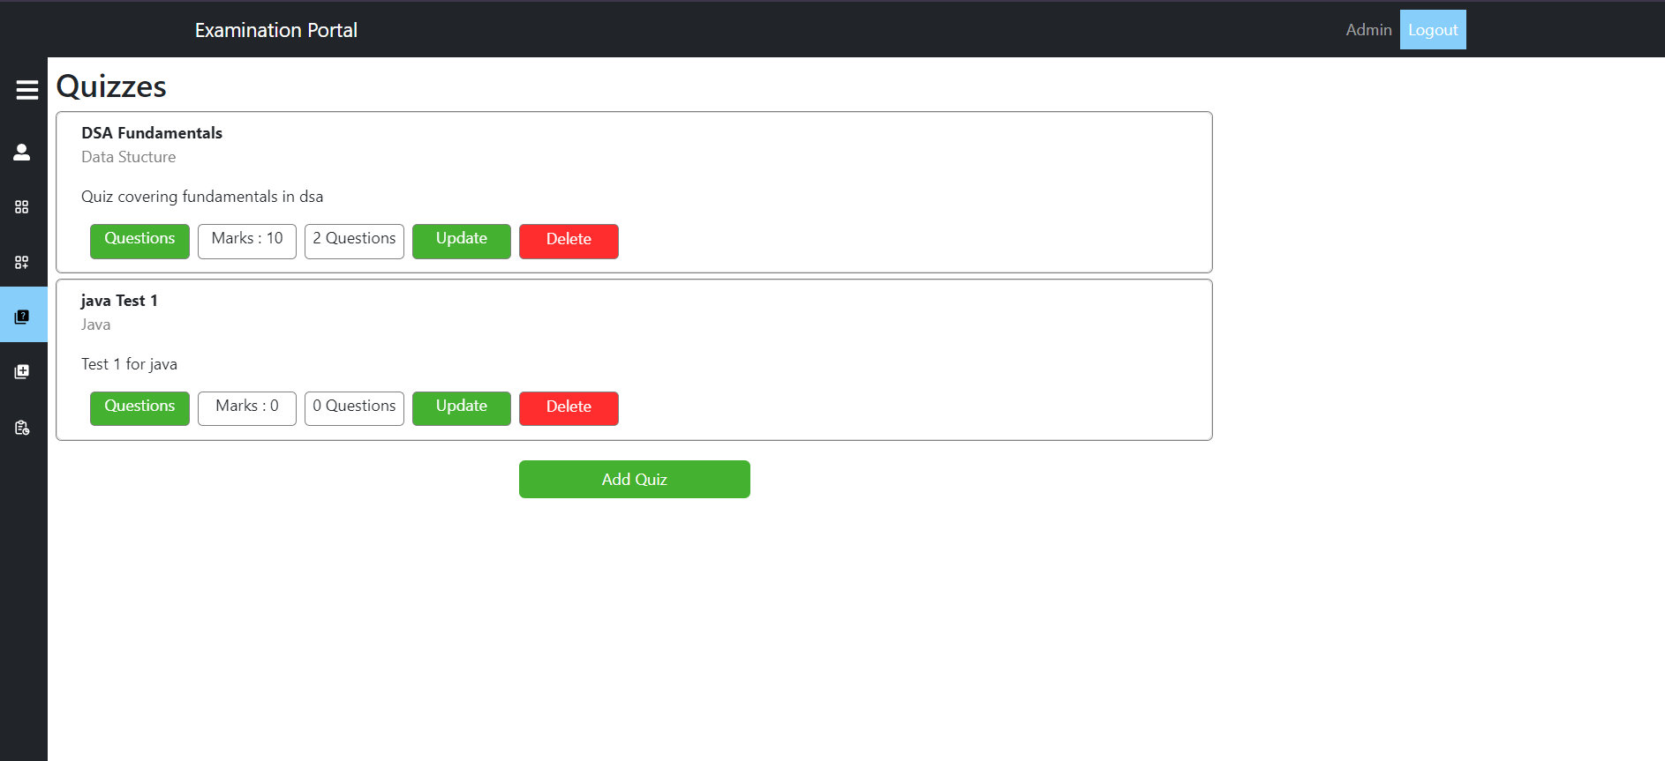

**Admin addQuetion Page:**

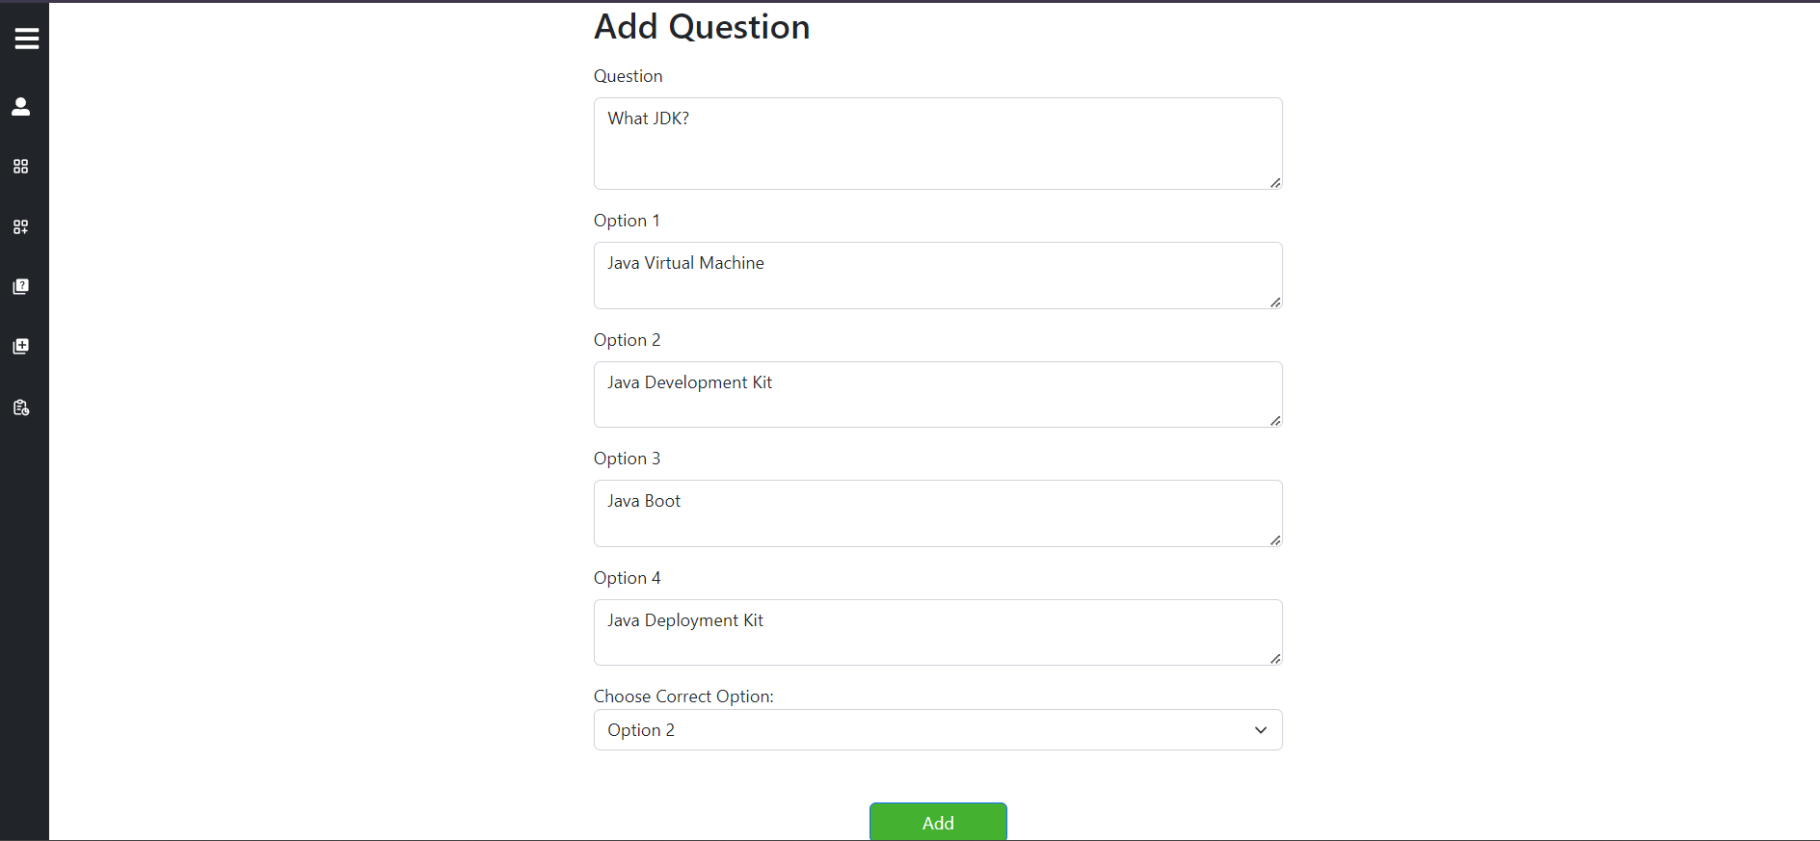

**User Quiz Page:**

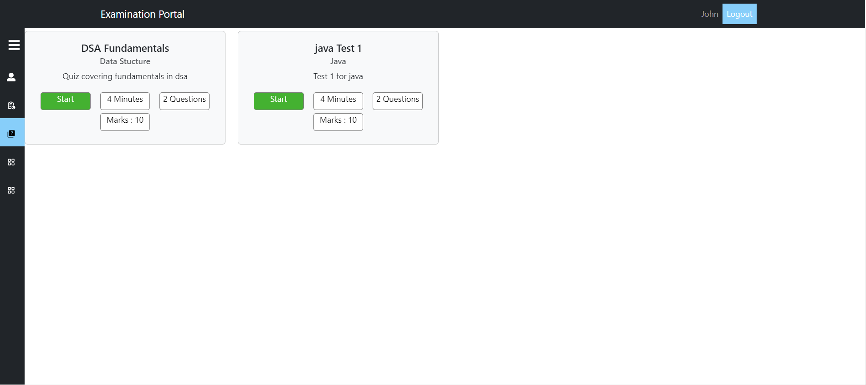

**Exam Page:**

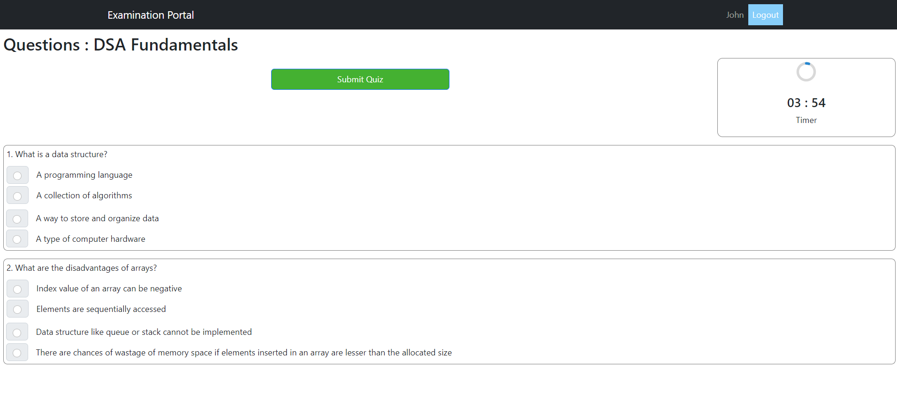

**Result Page:**

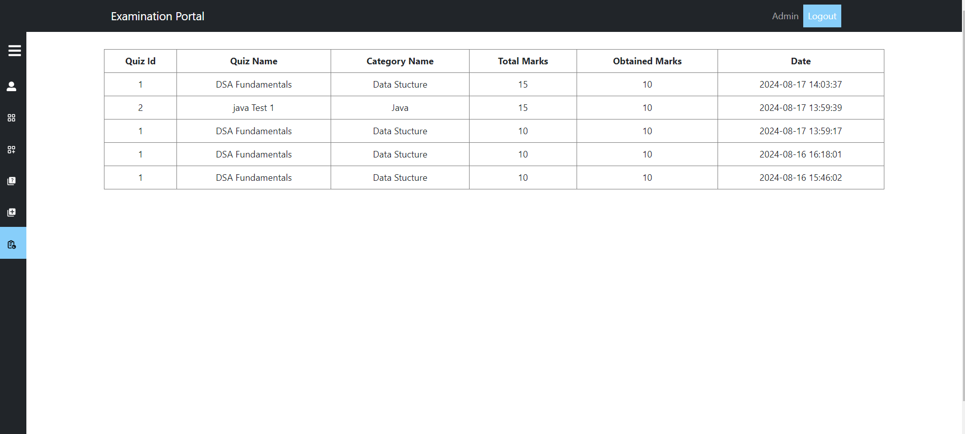

**Forgot Password:**

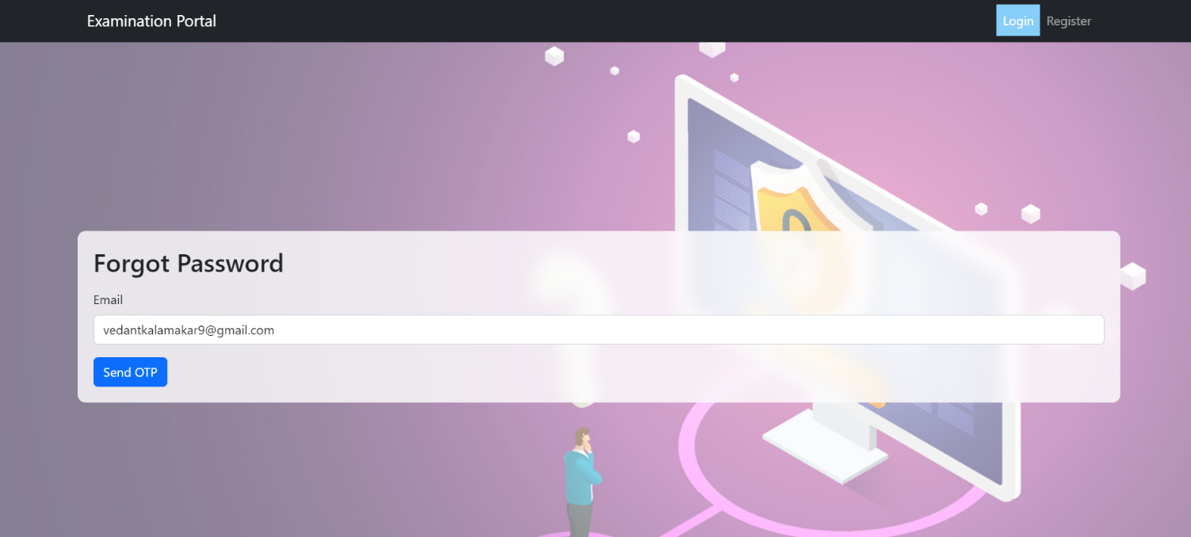

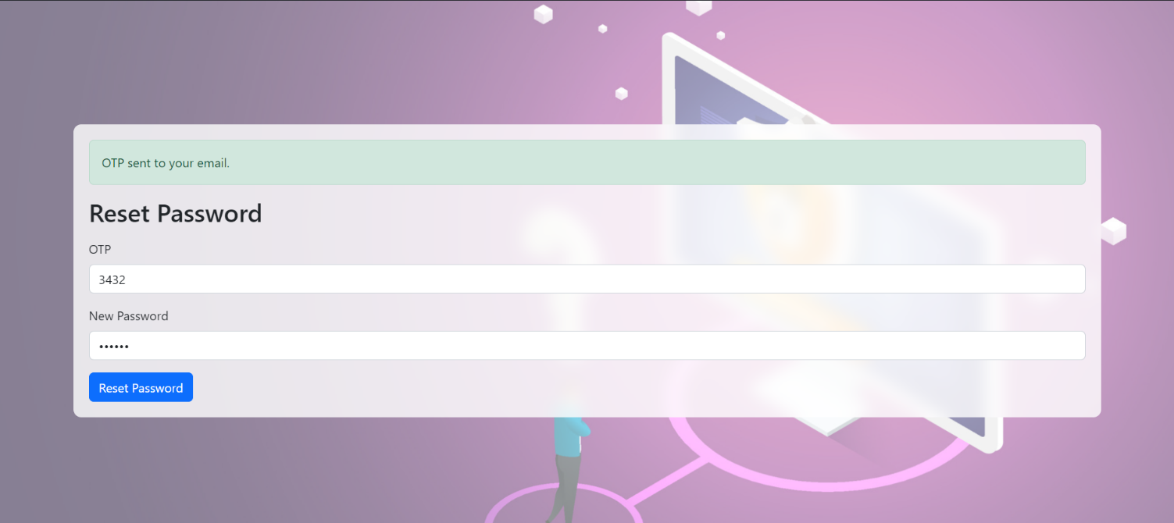

# 7. Conclusion

# The Examination Portal is a well-rounded solution designed to modernize the way exams are conducted in educational institutions. By shifting from traditional paper-based exams to an online system, it not only simplifies the administrative process but also provides students with a more accessible and flexible examination experience. The platform's user-friendly interface ensures that both administrators and students can navigate it with ease, while its secure design protects sensitive information.

# 8. Future Scope

# The Examination Portal has room for growth, including advanced analytics for detailed insights, AI-driven personalized quizzes, multi-language support, and integration with Learning Management Systems. Future enhancements could also include mobile app development, enhanced security, gamification, and collaboration tools to improve user experience and engagement.

# REFERENCES

<http://www.javatpoint.com/java-> tutorial [http://www.w3.org](http://www.w3.org/) [http://www.wikipedia.org](http://www.wikipedia.org/) https:/[/www.tutorialspoint.com/java](http://www.tutorialspoint.com/java)